

Written and updated by Steve Meadows, KHSSL Executive Director Special Thanks to
Rachel Page, Ryle HS, for her early drafts of similar work (for prior Page-s?) AND in September 2021! Woody Zorn, Hebron MS / Brian Huot, Wilson Wyatt Debate League, for writing the Debate section The KHSSL schools I’ve used as examples within, for being exemplary
May the scores be with you.

Note:
Setting up a tournament on Tabroom for the Kentucky Circuit assumes you have permission to do so as you’ve placed the tournament on the approved KHSSL calendar set at the annual Board of Directors meeting. For any additions or changes to this calendar, contact the Executive Director directly.
See https://www.khssl.org/tournament-calendar for the latest calendar and to double-check you’re on it. If you’re an out-of-state tournament bordering Kentucky and have requested to host your event on the Kentucky circuit, this won’t apply to you, but you WILL have to use Kentucky rules for events AND tabulation (and give the KHSSL Executive Director electronic access to your contest) to allow KY schools to count your speech meet for State qualification. If you’re an out-of-state debate contest, you’re good to go as is.

FIRST THINGS FIRST:

- You must have a Tabroom account and be the coach of the team hosting the KHSSL-approved tournament.
  - If you do, advance to step 2.
  - This isn’t going to be a Choose Your Own Adventure Book, but wouldn’t it be fun if it were?
  - If you don’t have an account yet, go to www.tabroom.com and click on Sign Up on the top of the screen. Sign up for your account and your school as per the online instructions. Request to join the Kentucky circuit.

- Log in to your Tabroom account.

- When you do so, you should pop up to a screen that shows Kentucky Circuit tournaments open for Registration on the left (and any other Circuits you’re a part of) and your current tournaments you’re registered for. Look on the right and scroll down to Request a Tournament. Click. This will send a request to the KY Circuit Tabroom Committee (also the Kentucky NSDA Committee + the KHSSL Executive Director) to list your tournament on the Kentucky Circuit. However, you should be able to go ahead and set up your contest before they click “allow.”

- On the screen that appears, type in the name of the tournament. Make sure the name of your school (and the level – high school or middle school) appears in the name of it as well as the creative name you’ve come with for it (i.e. Henry Clay High School Speak of the Devil) for easy recognition amongst scrolling schools on the Tabroom main site.

- As instructed, give the tournament a short version of it that will be used as part of your tourney URL by the program when it’s launched. Use the same one year to year. Note: if you try to use one used before by a prior coach, you’ll get an error message stating you don’t have permission to use that name. The easiest thing to do is just come up with a new name. Alternatively, you could contact the prior coach and ask him/her to make you an owner of the previous tournament in the Access settings, which would allow you to use that particular name.

- There is no number six.

- Fill in City/State/Country/Time Zone. PRESS THE SAVE BUTTON.

- Skip “Clone Setup of another tournament” unless you know of another Kentucky tournament ALREADY SET UP FOR THIS YEAR (the setup settings change every dang year, so cloning last year’s is a pain unless it’s your own) that is just like yours is going to be. If there is such a tournament, you can clone the other one and then go through the steps in this guide and adjust as needed. If not, you just skip this and go through the guide.

- Press the SET DEADLINES button.

SET REGISTRATION DEADLINES page
Fill out each line accordingly. Odds are that the date for the first and second entries will be the same (a one-day tournament). Make sure you put the correct date!
Depending on if you’re hosting an online tournament or an in-person event, you’ll want to leave yourself a few days before the actual tournament to prepare. I find it easiest to make the Wednesday prior to a Saturday tournament (three days) the deadline. Any less and you have a lousy Friday. People should be able to get their acts together by three days before. Wily coaches will tell kids they must commit by the Monday or Tuesday so they can get everything in by Wednesday. Wily coaches are the best, though they never catch roadrunners.
Note: I like to make all the deadlines the same as the registration deadline, but some coaches like to give teams an extra day without penalty for drops and such. Hint: if you make Wednesday the deadline, there’s no need to do this, and they really should pay fees for changes after that as it will be a nuisance for you since you don’t want to stay at the tournament site all evening Friday.

CLICK TOURNAMENT CIRCUITS button.

TOURNAMENT CIRCUIT(S)
Check the Kentucky box. Ignore the rest for now. CLICK TOURNAMENT LOCATION button.

SITE/ROOM SETTINGS
If you are hosting your tournament online, choose the appropriate box for the method you are using to run your online tournament.
If not, choose the tournament site for your tournament – look and see if your school/site shows up in the list of sites previously used for hosting a KY tournament. If not, create yours in the box below. You’ll be able to adjust the site (room numbers, etc.) later.

CLICK CREATE TOURNAMENT.

You will next see a page that says TOURNAMENT REQUEST CONFIRMED. You can continue setting up your tournament by going to the top of the screen, clicking on your email address in Tabroom, and then clicking on your tournament’s name (which should appear on the right side of the screen about halfway down). This is where you will access the management of your tournament henceforward. So do that.
Now it’s time to finish the tournament set-up.

SETTINGS TAB
NAME & INFO subtab
Name and time zone of tournament plus location should appear. You’ve already input these.

For the slot below, you’ll want to attach files. Can be added later if they’re not ready yet.

Logo. If your team has a logo (see some nifty ones here), upload that. If not, use your school logo, which you can steal borrow from your school’s website. This will put the logo on your tournament printouts and on some webpages and just look oh so much better and more professional than omitting this step. And why not have a logo contest on your team to come up with one for your school? Or talk to that kid at school – you know the one – who’s really good at these graphic designs? You need your own, eh?
Example logos from Beechwood HS and Danville HS and South Oldham HS:




You should see the Kentucky Circuit as Approved or Approval Pending, depending on how on-the-spot those KY committee folk are. If you want to add your tournament to any of the national circuits, the Wilson Wyatt Debate League, or if you are near another state that you think you might have folks drive in from, feel free to add that one too, and whoever administers that circuit will let you in or not as they see fit. As a point of order, the Kentucky Circuit is administered by the elected NSDA District Committee for Kentucky plus the KHSSL Executive Director (who at the time of this writing is on that committee anyway).

GENERAL subtab
General Settings
You’re going to ignore most of these. Here are the ones you click Yes or type in something: Require adult contact to register: Y
Tabroom Account Based Coaches and Contacts: Y Log registration changes: Y
Publish List of Registered Schools: Y School code style: Incremental First school code: A
SAVE SETTINGS (push this button, or this was all for nuttin).

Online Day of Registration
Most of the time KY schools don’t do this (just register in person when you arrive), but if you wanted to make this an option, just follow the steps indicated / answer the questions.
Notes on onsite registration page:

This is a note coaches will see when they start signing up for your tournament. So if you have big announcements you want the coaches to see, put them here
- We’re having a special fundraiser for Feed the Children, so bring canned goods with you to the tournament.
- We are having a pajama-themed tournament since we’re starting later in the day – feel free to wear PJs to the meet.
- This is our very first Middlesboro Mileaminute Debate meet! Thanks for making history with us!
- Etc.
Sometimes coaches cut and paste their Tournament Invitation into this space too. Whatever floats your goat.

Copy Settings.
This button is useless to you your first time. But next year, it’s your friend. Next year, all you have to do is fill out the info on the first page and then press this button. Then all you have to do is go in and make any changes from the prior year, but your set-up will be soooooo much faster. You’ll always want to walk through the latest version of this guide as a double-check, but you’ll have lots less typing to do.

DATES subtab
So in theory, when you look at these dates and times, they should all be the dates and times you already put in earlier. My experience has been that these often are off by 5 or 6 hours when you get to this tab. It’s real dumb. I suspect it’s some sort of relation to Greenwich Mean Time versus where we are, but it’s real dumb. So fix the times and dates as needed.

ACCESS subtab

You should be listed as the Owner of the tournament. If not, use the box on the right and your Tabroom email address to make yourself so.

Add in your helpers for the day if you know who they are (you can come back and add more people as you like). Make them Tabbers.

Add in the KHSSL Executive Director Account (khssl@khssl.org) as a Tabber. This way s/he can easily help you with your tournament as needed AND obtain tournament results. Your tournament does not count as a KHSSL-rules invitational if you don’t do this, and Steve gets grumpy if he has to ask you to do this when it clearly says to do so right here in this document you’re supposed to be using.

Auto Backups: put in your own email address there (Tournament Owner) and Add.

MESSAGES subtab
In addition to the Invoice Payable/address information, this is a good place to put other messages you want schools to see about how and when to pay you, to upload your school’s W9 form if you think folks will need it (ask your bookkeeper for a PDF copy), etc. If you’re taking electronic payments, this is a place to let them know how or where to do that.
Click SAVE MESSAGES when finished. You can always add to these later if you think of things to add.

HOUSING subtab

We don’t really use this in the K-Y, but in some states, especially those where driving hours and hours across flat square states is demanded for each trip or where two-day tournaments are common, it’s not unusual for hosting tournaments to also host the participants overnight in team members’ houses.
Really. I know it sounds nuts to us, but that’s the kind of stuff that goes here. You could also put hotel info for your town here, especially if you’ve worked out a special rate with a particular lodging establishment or two. Most of you can just ignore this one.

NOTES subtab
I like C-Sharp.

PAYMENT subtab
You’ll see something that looks like this:
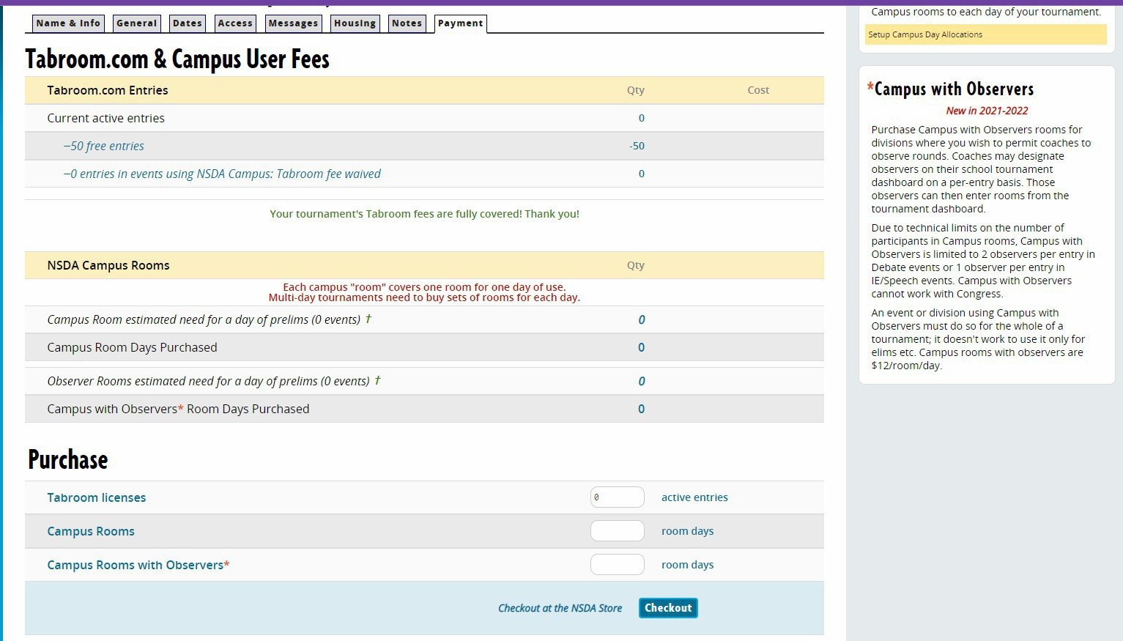
This is where Tabroom.com will charge you for use of the software. You get the first 50 entries free. After that you pay a fee per entry.
If you want to hold LIVE rounds using Campus, you’ll estimate those here and get charged here. You can update before the tournament starts once your registration closes and you know exactly what you need.
Be aware that you will have to pay the fees you owe NSDA online before you’ll be able to create rooms/sections/assign judges. So make arrangements with your school to either use a school credit card or to be allowed to be reimbursed for using your own sometime this week as you’ll literally get stuck in your own tournament program once you get to that spot. You’ll come back to this tab to pay, so remember where it is! Note the “Checkout” button at the bottom – that’s how you’ll pay your fees to Tabroom.

That’s it for the TOURNAMENT Tab under SETTINGS.

RULES & RESULTS TAB (under SETTINGS):

- TIEBREAKS tab

There will likely be a default collection of tiebreak rules on the right. You need to click on each of these and delete them away so we can set up the KHSSL rules tiebreak tabs.

Finished with that?

Now click on Add a New Set.

SPEECH PRELIMS:

Type in Speech Prelims as the name of the Tiebreaker Set. Check the Forfeits cannot advance/place last box.
Push the Create Tiebreak Set button.

Now you should see a new screen that has the info you just entered as the top 1/3 of the screen. Scroll down to the bottom 1/3 of the screen under Add New Tiebreaker. Time to make some Tiebreaker rules.

Tiebreak Type: Ranks Priority: 1
Click Truncate ranks to size of smallest section (This means that in prelims, if you don’t balance the rooms and you have a room of 6 in Extemp and a room of 4 in Extemp, the worst rank anyone will receive is a 4. This keeps it fair for the kids who happened to be in a bigger room – not their fault there were 4 kids in there. This is not a KHSSL absolute rule, but it’s one Steve always uses as he likes to run fair tournaments, and he’s really hoping you will too).

Use scores from: Rounds Marked Prelim Leave all the other boxes and clicks alone Create New Tiebreak – push this button
You should now see this rule listed in the middle 1/3 of the screen as the first Tiebreaker for Speech Prelims. Good job, you.

There are two more tiebreakers for Speech Prelims, so let’s create them.

Create New Tiebreak – push this button Tiebreak Type: Reciprocals
Priority: 2

Click Truncate ranks to size of smallest section (same rationale as before).

Use scores from: Prelim Rounds

Leave all the other boxes and clicks alone

SAVE SETTINGS (toward top of page) – press this button

Create New Tiebreak – push this button Tiebreak Type: Points
Priority: 3

Use scores from: Prelim Rounds

Leave all the other boxes and clicks alone

SAVE SETTINGS (toward top of page) – press this button

See next page for what your screen should now look like.

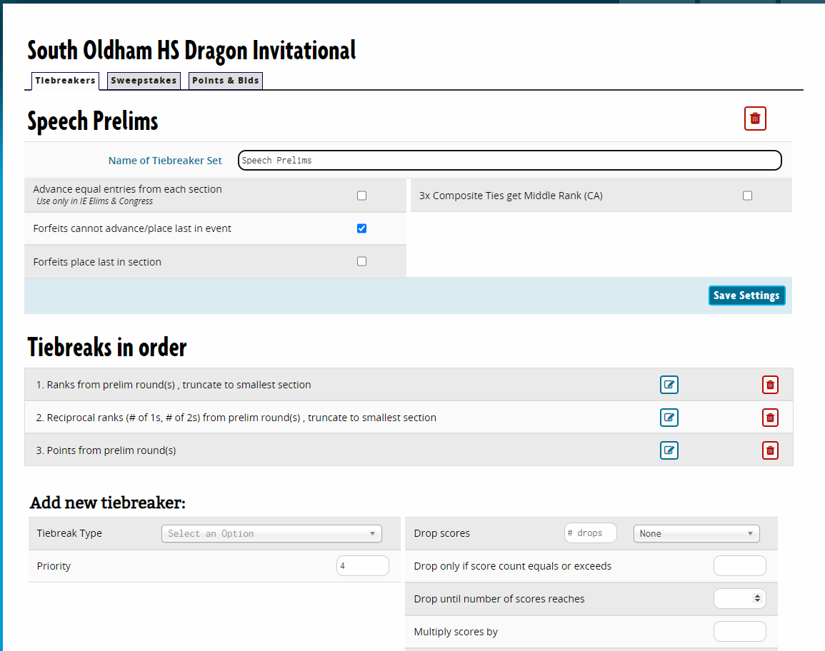

SPEECH FINALS:
Now you’re ready to make a new Tiebreak set for Finals. Up on the top of the screen, type in Speech Finals as the name of the Tiebreaker Set. Push the Create Tiebreak Set button. Create these tiebreakers.

Tiebreak Type: Ranks Priority: 1
Use scores from: Rounds Marked Final Leave all the other boxes and clicks alone Save these settings

Tiebreak Type: Judges Preference Priority: 2
Use scores from: Rounds Marked Final Leave all the other boxes and clicks alone Save these settings

Tiebreak Type: Reciprocals Priority: 3
Use scores from: Rounds Marked Final Leave all the other boxes and clicks alone Save these settings

Tiebreak Type: Points Priority: 4
Use scores from: Rounds Marked Final Leave all the other boxes and clicks alone Save these settings
See next page for what your screen should look like.

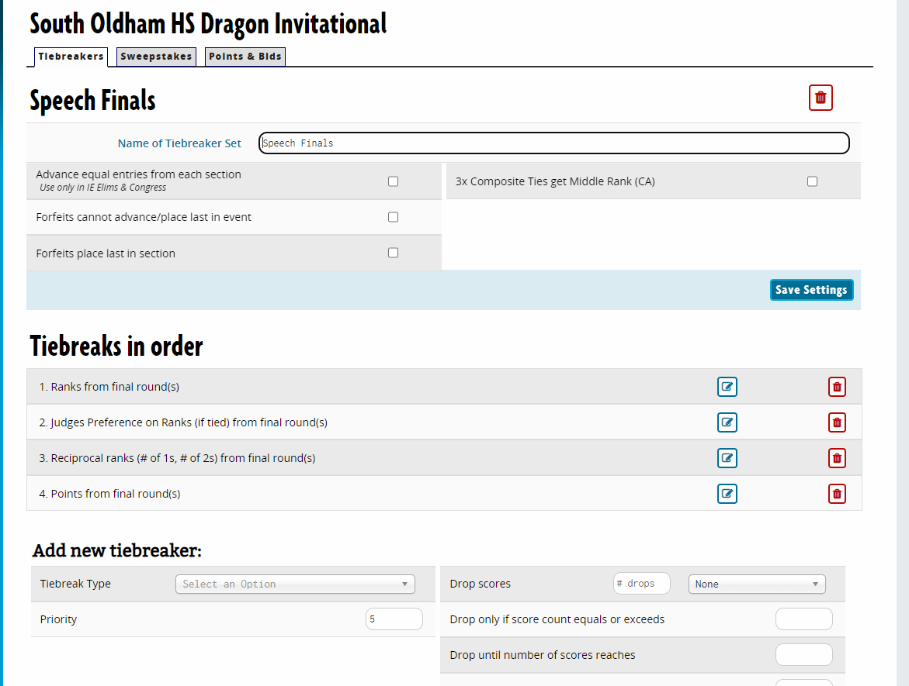

Yay! Time for the Sweepstakes Tab!!!
However, until you set up your Judges and your Events, you won’t be able to do some of this, so we’re going to journey on to work on the Judges Tab and the Events Tab and come back to Sweepstakes.

JUDGES TAB under SETTINGS:
- Settings: Judges
- Name: Speech Judges
- You now have a choice. You can suppress judge codes (names only) – if so, put Y. Or you can assign judges code numbers (say No and then put in 1 as your first judge code). I used to like numbers but now like names. Whatever makes your boat float. With a goat. Sam I am. I am Sam.
The rest of these items you can see in this picture. Just trust me on these. Make sure to put in the date you set up under Dates on page 6 if it’s not already there (for when judges info is due) and to use whatever fee you’re charging for judges schools don’t provide (the $30 in this example is low, btw). Click Save Registration Settings when finished and then move on to the Hires tab of Judges.

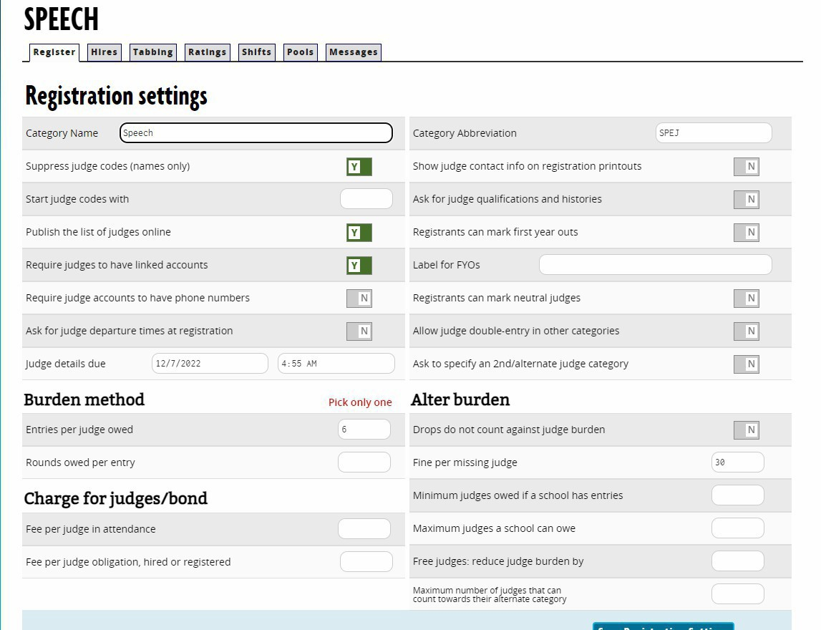

- Hires Tab:
You probably don’t need to fool with the first choice here as you’re already charging a fee for missing judges.
If you want to enable outsiders to come to your site and sign up to judge (say you want alums who want to help out to sign up that way), this is where you enable that and then set it up however you like.

- Tabbing Tab:

In the left column, the only part you need to check is optional. If you want to allow panels w/same school judges (this will only happen in finals), check Yes. This can be helpful in small tournaments or any Junior Division or Debate meet. Your call. You could also let judges get the same event twice (they won’t get the same kids twice), but in my experience, they don’t like doing that, so I say N on that one.

On the right column, on Ballot Hand Entry click Enter twice option; click Y for the following items:
  - Show school codes on ballot entry
  - List entry names
  - IE Piece titles/question
  - IE: Space for times
  - Space for judge signature

- There is no number 6.

- Ratings/Shifts/Pools – for normal tournaments, you don’t need to do anything here.

- Messages: Good places to thank judges for judging, tell folks where you want ballots turned in if using paper ballots at an in-person tournament, etc. Also a good place to let folks know about stand-by policies for rounds they are unassigned for judging (including finals).

If you are holding a tournament where judges are there in person but are doing ONLINE (not paper) ballots, this (Message when Schools Register Judges) is a good place to explain what you are doing – paper ballots, judges must bring their own devices (and phones don’t count), etc.

Time for the next major tab. Go to SETTINGS/EVENTS.

EVENTS TAB:
You will be repeating the process pages 15-16 for each event listed here.
Junior Speech (12 events): Senior Speech (14 events):
Declamation (DEC) Declamation (DEC)
Dramatic Interpretation (DRA) Dramatic Interpretation (DRA)
Duo Acting (DUO) Duo Interpretation (DUO) Extemporaneous Speaking (EXT) Extemporaneous Speaking (EXT) Humorous Interpretation (HUM) Humorous Interpretation (HUM) Impromptu Speaking (IMP) Impromptu Speaking (IMP)
Improvisational Duo (IP2) Improvisational Duo (IP2)
Oratory (ORA) Informative Speaking (INF)
Poetry (POE) Oratory (ORA)
Prose (PRO) Poetry (POE)
Radio Broadcasting (RAD) Program Oral Interpretation (POI)
Storytelling (STO) Prose (PRO)
Radio Broadcasting (RAD)
Storytelling (STO)
Note that if you have Congress or other Debate events OR if you are hosting other events that aren’t in these lists (Impromptu Storytelling, Solo Overacting, Tabloid Extemp, etc.), you can use these methods to add speech events (use the Debate section to add Debate events including Congress), but KHSSL Tabulation rules require that ONLY the 12 (Junior) or 14 (Senior) events count for Speech Sweepstakes. Otherwise, your tournament will NOT count for KHSSL qualification.

Steps under the Settings: Events Tab:
MAIN
- Add event
- Full Name: Type name of Event
- Short abbreviation – see list on prior page for the ones generally used
- Per Entry fee – type in the amount you are charging per entry. Folks often charge double for Duo events.
- Minimum and Maximum competitors per entry is 1 for all events save the duos, where it’s 2.
- Clone settings of – ignore this.
- Judge Category – for speech events, you’re going to use one called “Speech Judges” you already created.
- Entry Codes – choose Numeric.
- Start Codes with – most tournaments use a separate “hundreds” for each event – Broadcasting starts with 100, Declamation with 200, etc. Be sure to keep track of these as you add each event – multiple kids with the same code number because you started two events with “400” will be a problem.
- Event type: Speech
- Event level: whichever level you’re hosting for this event at this tournament – either Open/Varsity for Senior Speech or Middle School for Junior Speech.
- Box at the bottom – add this in the part that asks for the event description: SEE KHSSL HANDBOOK: https://www.khssl.org/handbook-and-constitution
SAVE
REGISTRATION
You don’t need to adjust anything on this page.
ONLINE
Ignore this tab if you are hosting a live/in-person tournament. If you are hosting your tournament online, click that.
If your tournament is online and live (synchronous), do nothing else. If your tournament has asynchronous elements to it (students’ videos will be watched by judges for some or all rounds),
On the Online tab, toggle “Online event” and select the setting “Asynchronous links to online videos”. Do this for each event that will be held asynchronously. This setting will create a space for coaches to copy/paste a link to a video in the entry details of any student entered in an asynchronous event during the registration process. Use this option if you would like competitors to record their video on an external platform and submit the link to you via Tabroom.com. This is what coaches will see on their entry: 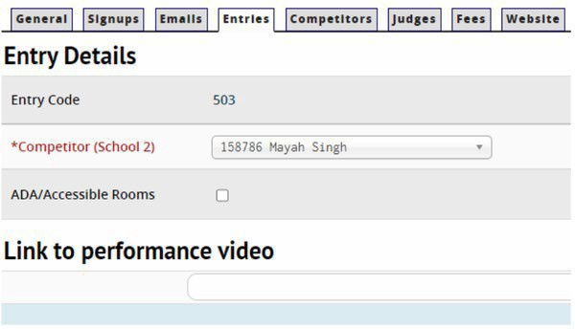
SAVE ONLINE SETTINGS

SECTIONING
Section Labels – choose if you want numbers or letters. Doesn’t matter which. I like letters – makes it less confusing when you have a room number too, but most people just use numbers.
List Entries by – Codes
Use same rooms round to round – Y
Default section size – 6 Minimum – 5 Maximum – 7
Click Y on “Use Same Rooms Round to Round” as it will save you a lot of time assigning rooms.
Leave everything else alone (most are pre-set at N) on this page except click Y on “Anonymous entries on public pairings (codes only)” so kids can’t check each other out and psych each other out. Also click Y for “Enable Live Updates.”
SAVE SETTINGS

TABULATION
Input: Whole point Increments, Minimum points 70, Maximum points 100. Online Ballots: IF using these
Y for Online Ballots if using these. If using paper, leave as N. If online ballots is Y, then below it put these items:
Minimum points 70, Maximum 100
Comments minimum word count – put at least 10 words as minimum. Judges should say something! Default speaker time 10 for most events; see event rules for limited prep events
If using Paper Ballots, make sure Online Ballots is checked on N. SAVE TABBING SETTINGS

BALLOT & RULES

CLICK HERE TO ACCESS THE JUDGE INSTRUCTIONS MASTER DOCUMENT
If you are hosting a virtual tournament OR using ONLINE BALLOTS at an in-person tournament,
  - Click the link above and download the Judge Instructions Master Document.
You can also get to this page via the Ballots page under Tournaments on the KHSSL website.
  - Cut and paste the first page of the document (the ratings guide) and put it in the box MESSAGE BENEATH THE SCORES for each event.
  - Post the appropriate rules for that specific event into the online ballots in the TEXT ON TOP OF BALLOTS space. Post the whole page (summary of rules, judging criteria, etc.). Now the judges have it at their fingertips as they prepare to judge. Easy peasy. Stare at carrot.
SAVE MESSAGES
If you are hosting an in-person event with paper ballots, this is all on the paper ballots, so ignore this page.

UPDATES
Read through the description here and decide if you want these updates. If you don’t, ignore this page.

REPEAT THE STEPS ON THIS PAGE AND THE PRIOR 2 PAGES FOR EVERY EVENT IN YOUR TOURNAMENT!!!

Time to return to the part of the tournament we skipped over to do Judges/Events.

RULES & RESULTS TAB:

- SWEEPSTAKES Tab

Again, there may be default entries over there from Tabroom. Thanks but no thanks, Mr. Tabroom. Delete these.

Click on Add New Set and type in KHSSL Sweepstakes and then Add. You’ll get a new screen to type in entries in some boxes and to ignore some boxes.

SETUP:
Entries counted per event: 3 Events Counted: All
(note: if you are offering any non-speech events or non-KHSSL speech events, you should NOT choose All here but instead should only add in the KHSSL events).
Save Setup button.

ADD RULES:
PLACEMENT/SEEDING
Placement: Any entry placing 1 10 points
Basis for placement Speech Finals
In Speech Finals
(repeat this process for 2nd, 3rd, 4th, 5th, and 6th 7, 5, 3, 2, and 1 points, respectively).
Hint – you can see these become RULES as you put them in if you look under RULES.

ADD RULES (continued)
At the bottom of this page, you need to add in the Prelim Rounds ranks points. It will vary depending on if you have two prelim rounds or three prelim rounds in your contest. See below. Whichever method you have to input, be sure to click Prelim Rounds at the bottom each time.
SWEEPS FOR PRELIMS IF YOU HAVE TWO PRELIMINARY ROUNDS FOR SPEECH EVENTS:
Each entry having a composite rank of 2 or 3 is worth five points while a composite rank of 4, 5, or 6 is worth three points and a composite rank of 7, 8, or 9 is worth one point.
SWEEPS FOR PRELIMS IF YOU HAVE THREE PRELIMINARY ROUNDS FOR SPEECH EVENTS:
Each entry having a composite rank of 3, 4, or 5 is worth five points while a composite rank of 6, 7, or 8 is worth three points and a composite rank of 9, 10, or 11 is worth one point.
So to add in Sweeps points for your tournament, you will do the following on the Add Rules page: (bottom of page) RANK CUMULATIVE TOTALS (IE/CONGRESS)
TOTAL RANKS OF 2 5 points Prelim Rounds only (bottom choice)
Repeat all the way through a total of 9 Total Ranks for 2-rounders, 11 Total Ranks for 3-rounders
When you’re finished, you should be able to push the RULES button and see a chart that looks like this picture for a three-rounder or something similar for a two-rounder (with the corrected points).
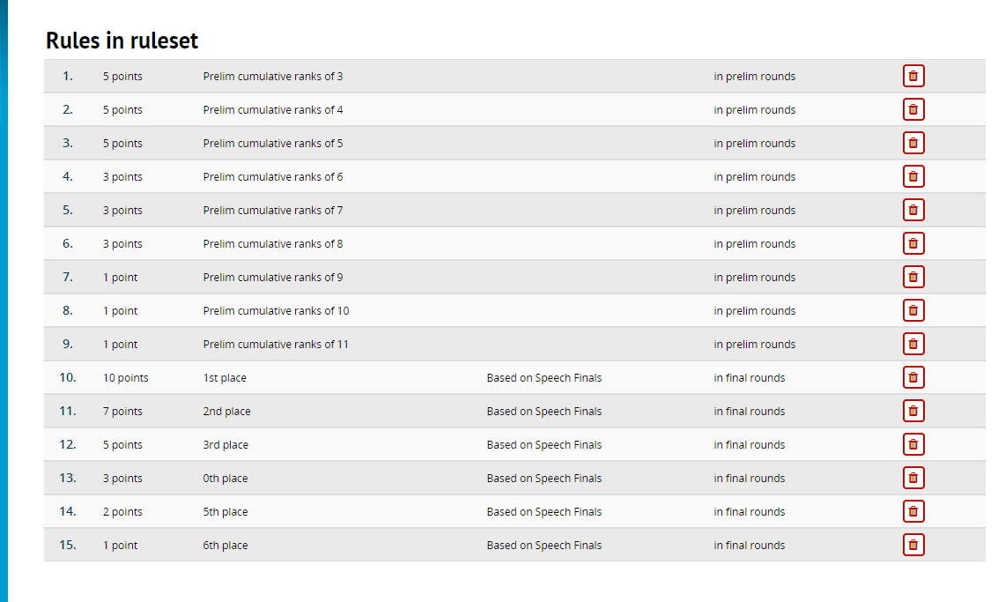

- POINTS AND BIDS Tab You don’t have to do anything here unless your tourney is a TOC Speech
prequalifier, and you’ll know that as you applied for it. Contact Steve for help if you want to know more or are doing this.

SCHEDULE TAB:
This one’s pretty simple. Just be sure to put in the proper dates and times.
If you are running an asynchronous tournament, you CANNOT schedule rounds at the same time (the entire time judges have to judge the prelims, for example). Instead, you have to put the rounds in separate time slots (Round 1 8-10, Round 2 11-1, etc.), or your judges will only be assigned to judge once. It really doesn’t matter what times you put here – the judges can judge the rounds whenever you’ve blasted out the ballots for that round.
AFTER you have assigned judges, go BACK to the Schedule and make them all end the same time for an async tourney.
If you are running a live tournament, just use the times you’re running those rounds, obviously.
For the Label for each round, just type in Round 1 or Finals or whatever’s appropriate. You'll need to check the boxes for each round you've created so the event will hold those rounds, which will then trigger a warning about no tiebreakers set for those rounds. Mark each round as a Prelim (rounds 1-3) or a Final (Final) Choose the KHSSL prelims tiebreaker for the rounds 1-3 and the KHSSL finals tiebreaker for finals (you can see what it should look like under Junior Broadcasting). Rinse and repeat for all the other events. (orange parts added 10/16/24).

SITES AND ROOMS TAB:
Another simple tab. If you are hosting in-person or completely asynchronous, you can simply create a Site (see on the right side – Sites/ Add/edit tournament sites) and then add room numbers. If you have never held a contest in your building before and you are all asynchronous, you can just make up room numbers; you can also use already-established room numbers for an asynchronous tourney as the rooms are really sort of theoretical. Feel free to use mine (Skynet).
If you’re using Campus, the program will assign you room numbers when you click on the Configure NSDA Campus button on the top right and follow the instructions for that service.
Some folks go crazy with Room Pools and assigning certain rooms only to certain events. I find this more trouble than it’s worth. I do think it’s a good idea (for in-person tournaments) to put Notes in the Notes section for each room about very small rooms useful only for Extemp or Broadcasting. Other than that, why complicate life for a normal tournament?
If hosting a live tournament, just add rooms. They’ll be there next time you host, and you can adjust as needed.

MONEY TAB:
This tab has several links that should already have information in them as you’ve put this info in other places. If you want to pre-sell concessions or something like that, you can use the tabs here to do that. Most people running normal
Kentucky in-person tournaments or online tournaments won’t have to do anything with anything in this section. If the21
nuisance fees don’t show up for you here, add them in (drop fees, add fees, etc.).

WEBSITE TAB:
This tab has links to several pre-established pages folks can click on when they go to your tournament website on Tabroom, and you can also see the direct URL to access your tournament on the web on this page.
You should definitely add text to the Main Page (some people put their whole invitation there). A friendly greeting and a sales pitch for your tournament pointing out unique features of it would be good here. Lots of folks copy the first paragraph from their tournament invitation and put it here with instructions to see the posted invitation.

POST YOUR INVITATION AND LEGISLATION FOR CONGRESS HERE:
These can be done at any time, but you should post the Invitation ASAP.
Go to the Uploaded Files link under Postings on this page, click it, and then Add New for your file of your tournament invitation and/or Congress legislation. Post it to your Front Page.
- Invitation. This should be a full document (Word or PDF format) that explains everything your coaches will need to know about your tournament (parents and students too). It takes a while to write it all out, but once you do, minor updates will service the use of this same document annually. Look at others already posted for this year for examples, or browse here:
www.speechanddebate.org/wp-content/uploads/Sample-Invite-Tournament-of-Firsts-2018.docx

- Congress Legislation. If hosting Congress as part of your tourney, post the packet of legislation here in PDF format.

- The Upload Files/Postings tab is useful if you want to do something like upload the KHSSL Handbook or something (although it might be easier just to make that a link on the Main page) to tell folks what rules you’re following.

- Don’t worry about the other Tabs.

SPEECH ADDITION ADDED 7 DECEMBER 2022 (WHAT TO DO ONCE REGISTRATION CLOSES):
Once your registration has closed, please take the following steps to get your room scheduled and judges assigned.

ELIMINATE EMPTY ENTRIES.
ENTRIES/SCHOOLS
Under this tab, flip through each school and make sure each school has at least one entry/judge included.
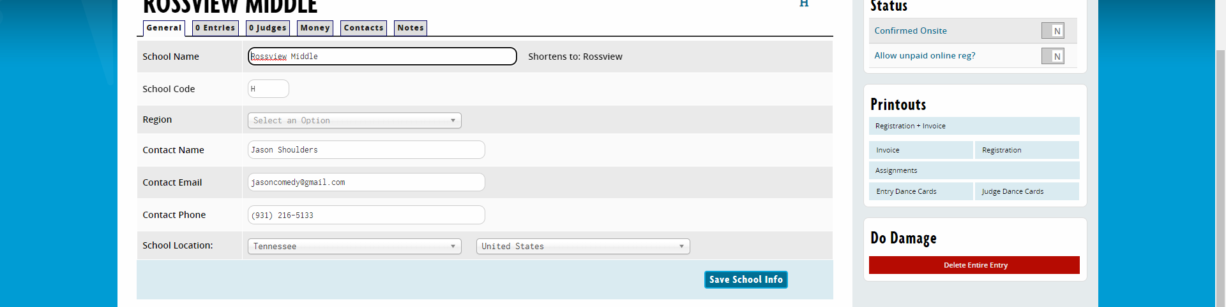
If there are any with no judges and no entries, you should delete that school so it won’t show in the tournament (just confusing for everyone – they’re not actually participating). To do so, click on the Red DO DAMAGE button on the right side of the school page and follow instructions to delete the school from your tournament.

Contact schools if needed.
If you have schools who are not providing judges or who just have judges but no entries, you may wish to reach out to them as there may be an error.

- Time to panel the prelim rounds. Here’s what Tabroom says to do.

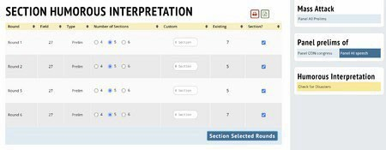
To get started paneling prelims in Speech, use the "Rounds" menu item. You will then be given the option to panel all speech events at once (recommended), or one at a time:
If you choose the "Mass Attack" option, you will see a list of events, where you can choose the number of sections to create. Tabroom will try to evenly distribute entries through the number of sections you choose - so the more sections you use, the smaller the average section size will be.
If instead of "Mass Attack," you choose to panel a single event, you will see a similar screen that lets you choose the number of sections to use for each round.
If you need more control over the pairing process, you also have the option of paneling only a single round, direct from the schematic. Use the Schemats menu to view the round you want to pair, then select "Panel this round only" from the sidebar to automatically panel that round. If you instead first create the number of sections you want to use with the "Create additional sections" box, the auto-paneler will split up students into that number of sections.
Note: KHSSL default for state tournament is 7 competitors. Don’t put more than 7 in a room – ever. Steve’s rule of thumb is to default to 7 as the norm for most rounds and to 6 as the norm for limited prep events. It makes the tournament efficient in room/judge usage while also keeping the tournament running on time. If you have shorter rounds, you may wish to adjust down, but you always want at least five entries per round unless there’s a really good reason not to.
If you’re going to use special (small) rooms for Extemp and Broadcasting, you may wish to do those events first and hand-assign the rooms. Then you can do the rest of the events and just let the tournament program auto-assign the rooms. You also might want to make sure the rooms you assign to Improv Duo have 2 chairs and a little room. If a Junior Speech tournament, ditto for Duo Acting.

4. Time to deal with judges.
Go to Entries/Judges and look at your list of judges. If there are any notes about judges (“Myrtle can’t judge round 1”) or other such ridiculousness, you need to input that info into Tabroom before you give Myrtle Extemp round 1 and your tournament comes to a halt because there’s no Myrtle there.
To strike a judge from availability for a round, here’s how:
ENTRIES JUDGES
Click on the Judge’s Name on the left. Click on Strikes up in the top right.
Go down to Time Based and click on the drop-down menu. You’ll then be able to click on a round, and that judge won’t be able to be assigned for that round. Repeat this process if you need to do more than one round. You should see those rounds come up on the right side of this page (under Tabroom Only). That means they’re blocked from those rounds.
Note that judges are expected to be available for all rounds, including finals. If the school has not provided extra judges beyond what they owe, being unavailable for a round means they owe you some money for missing that round. Bill accordingly – whatever you think is fair as a part of the judge fee for the day (at least $10 per missed round).

Once you have all these completed, you’re ready to pair the judges into the rounds.

This is easy. Go to PANELING / JUDGES / and then choose one judge per round and All Rounds. Watch the magic happen. If you don’t have enough judges it won’t be able to place all rounds with judges, which is when you call me for help. I often know tricks to get more use out of judges, but I can’t create them out of thin air either, so recruit judges always.

You should now be ready to print out dance cards, run ballots if you need to run off paper ballots, etc. Here are some tips for those. Don’t forget to look at the official checklist too (click here: https://www.speechanddebate.org/wp-content/uploads/So-You-Want-to-Host-a-Tournament-Checklist.pdf

- Print list of schools with the school codes (letters) on it so you can use it to make TWO copies of the big FOR-THE-TEAMS envelopes. One is for registration packets (what you'll stuff things into) and one is for ballots to go into on Saturday. ENTRIES / REPORTS / SCHOOL LIST

- Run dance cards for judges and students and stuff them in packets: ENTRIES / REPORTS / BY CATEGORY / BY SCHOOL NAME

- Run ballots off if using paper ballots
# of sections x 3 (for three rounds) + 4 extra packets (finals judges and one extra packet)
DON'T FORGET TO TYPE IN THE NAME OF YOUR TOURNAMENT AT THE TOP OF EACH BALLOT PACKET (ON ONE OF THE ACTUAL BALLOTS).
Ballot link: https://www.khssl.org/ballots
*Once you've run off ballot packs, attach impromptu topics to the impromptu ballots, improv topics to the improv ballots, and the round 1 (only) Broadcasting scripts -- one for each kid plus a judge -- to the Broadcasting ballot packs for round 1.

- Impromptu topics -- 2 quotes per section per round plus an object for finals Samples: https://www.khssl.org/copy-of-limited-prep-practice

- Improv duo topics -- 1 topic per section per round including finals. USE HANDBOOK GUIDELINES FOR HOW TO WRITE TOPICS FOR EACH ROUND.
Samples here, but realize the topic procedure changed a couple of years ago, so USE THE HANDBOOK for proper way to write topics. https://www.khssl.org/copy-of-limited-prep-practice

- Extemp topics -- 10 to 12 topics per round; copy same topics for the round into multiple envelopes (one for each section you have)

- Broadcasting Scripts --
  - Samples here: https://www.khssl.org/copy-of-limited-prep-practice
Round 1 Commercial -- write a thirty-second commercial (no longer than one page) in all caps.
Round 2 -- Students bring themselves
Round 3 – BREAKING NEWS – write the script.
Finals -- provide about ten news stories and a topic for a commercial (with a few fun facts listed about the product or service)
  - You need copies for each kid in the round plus the judges when you run copies for Broadcasting.

- Print off Registration and Invoice with Room Assignments -- 2 copies
ENTRIES/REPORTS/COMPLETE PACKETS/Reg & Invoice w/Room Ass'ts
Don't stuff either copy into the school packets. At registration, hand one copy of the registration to the coach and ask them to note any drops or substitutions. Keep that copy and give them the other one. Add any charges for drops to the two invoices and sign one as their receipt -- they keep that one. Fold the other one over with the money or check they give you inside it. Makes tallying it up and keeping track of who paid what later much easier.

FINAL NOTES FOR SPEECH TOURNAMENTS:

SUPPORT

- Your Executive Director is your go-to person for tournament support before and during (and even after) tournaments you are hosting. While I always appreciate emails instead of texts (as a part-time hourly worker, I don’t like being told when to go on duty by others), that’s out the window when it comes to tournament support in a time-sensitive situation like anytime on Saturday of most tournaments or when you have deadlines almost due or have a shut-down or lock-up of your tournament. So please text me at 859-927-1100 as needed; if it’s something that can wait up to a day (your tournament doesn’t start for a week or something), please email me at the KHSSL address (khssl@khssl.org), and I’ll get back to you within 24 hours. On tournament Saturdays, I consider myself on call all day, so no worries – call or text.

- Tabroom Help: If you are a do-it-yourself-er, you can always look through the Tabroom Help files (the Community Forums are helpful there too) by clicking on the Question Mark (?) circle up at the top right of the Tabroom page. This won’t help you with KHSSL-specific questions as this program is used all over the world with lots of rules sets, but it will help you with Tabroom management.

- You can also ask for help from other coaches, obviously. If you are a rookie and have an assigned mentor (or had one the last few years), that’s your go-to person. But I do ask that you try to take it easy on asking other coaches. Many of the coaches in our League are fantastic people who will give you far too much of their personal time to help you, and one of the reasons y’all hired me was to give them a break after a council of coaches ran the League with no employee on hand for two years. The same people get hit up by everyone for help, and they all got the same stuff to do y’all do. So put me to work. I get paid to be helpful.

HAVE A GREAT TOURNAMENT! --Steve Meadows, 10/1/25 update

DEBATE EVENTS (by Woody Zorn and Brian Huot)
The following infinite pages, including page 6 (sorry Steve), are in-depth instructions at setting up Tabroom to run your very first debate tournament. The beginning of the document, for general tournament setup, still applies whether you are adding debate events to a speech tournament or running a debate tournament exclusively. This section will focus on how to set up the most common events in KHSSL debate.

Main Settings
The Main tab is home base for your event and the first page you will see after creating a new event. Notice the green box at the bottom of the left column: Clone settings of:. After your first debate event is created, this will allow you to copy the settings to every subsequent event you create. Novice LD to Varsity LD, Novice PF,
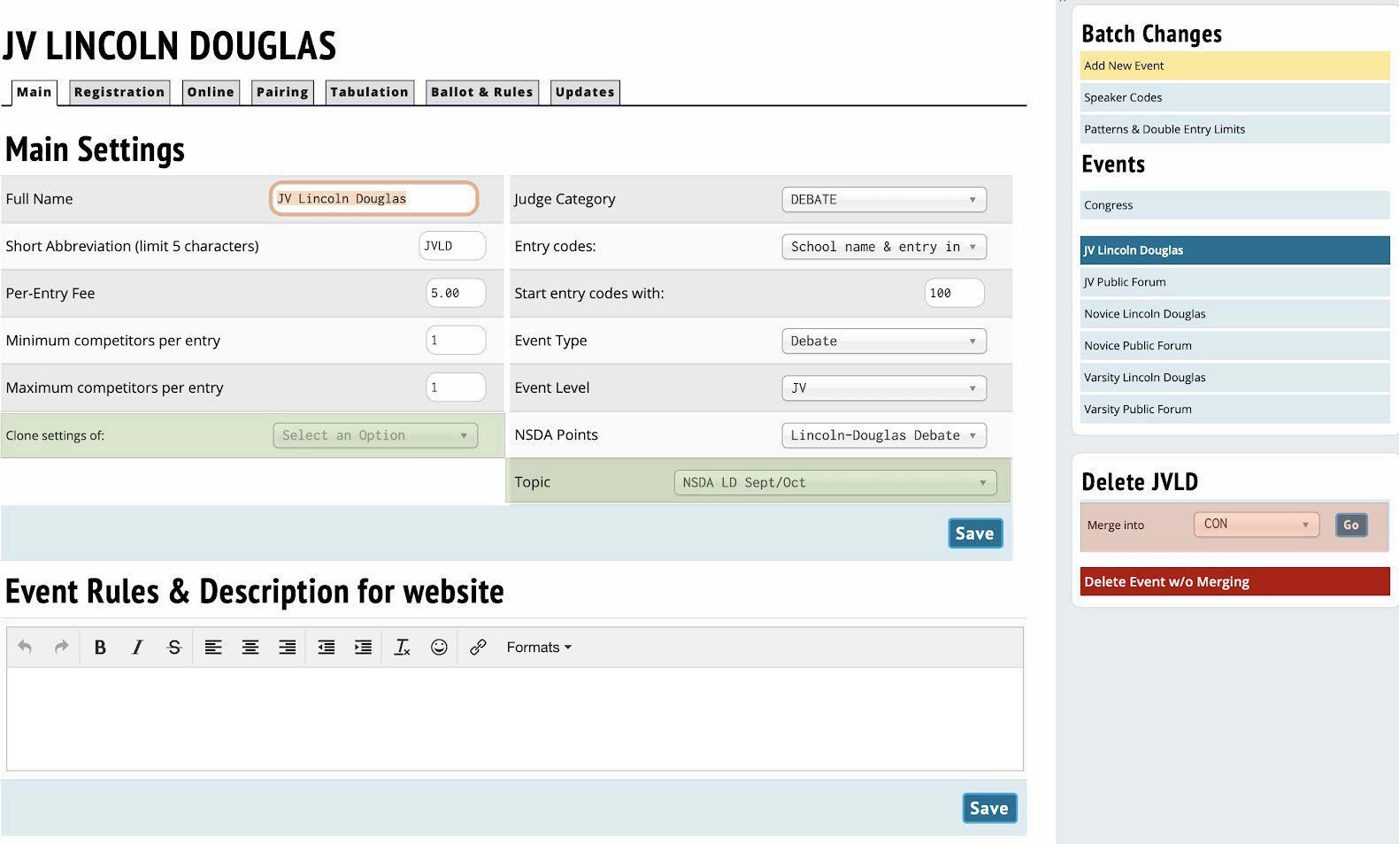
Varsity PF. After that, you only have to skim
through the new events and make small changes.
Working through the page, the rest of the settings will look like:
- Full Name/Short Abbreviation: The name and short code of the event, as they will be used throughout Tabroom and on ballots. Typically, Lincoln Douglas/LD, Public Forum/PF, Cross-Ex/CX or Policy/CX, and Congress/CON. If you are using divisions at your tournament, you would want to prepend each with Novice/N, Junior Varsity/JV, and Open/O or Varsity/V.
- Per-Entry Fee: This will be filled in already from your Money tab when you created the tournament, if you selected a Per-Entry fee. If not, you can add one now.

- Minimum/Maximum competitors per entry: Like speech, these should be set the same, at 1 for LD and Congress, and 2 for PF and Policy. It is considered bad practice to allow mavericks (single debaters in PF or Policy) or 3-person teams to register at the start, although they may be created mid-tournament if necessary due to illness.
- Judge Category: This is the judge category the event will draw from by default, and where teams must assign judges in order to meet their quota. It is sufficient to use one category if you are only hosting LD and PF debate, and even Policy can be included in that category if it is a small division. However, Congress (and speech events) should always be separate categories. They require different burdens, as well as different skill sets to judge. Earlier in this document, the creation of judge categories was covered for speech events. This process is mostly the same for debate events, but a few modifications are required:
  - Entries per judge owed: 2
  - Abbreviation: Highly recommended (DB8, CON), since Tabroom uses the abbreviation in many places
  - Under Tabbing > Judges can get same event twice: Y. Because you will need a judge more than twice in a tournament.
- Entry Codes/Start entry codes with: Choose how you want students to appear on pairings and ballots.
- Event type/Level/NSDA Point: Select whether this is Debate or Congress, which level of debate it is, and then ensure that the correct method of calculating NSDA points is assigned based on the style of debate.
- Topic: New this year, Taboom will directly import the NSDA topics! Simply choose which topic your tournament is choosing directly from the pulldown menu. If you are creating your tournament too far in advance, the topic may not be available in the list yet - that’s okay! Just be sure to go back and double check everything closer to the magic day.
- MERGE/DELETE: First, unless the event is completely empty, never hit the delete button. But, let’s say you wanted to try to hold a Novice division and only one poor, unfortunate soul registered. You merge with the Varsity division of that event by choosing it from the drop down menu and clicking Go. Problem solved! Novice debater sacrificed.

Registration
The Registration tab allows you to tailor event-specific settings. For most tournaments, the default settings will be fine because they were set based on your tournament-wide registration settings.

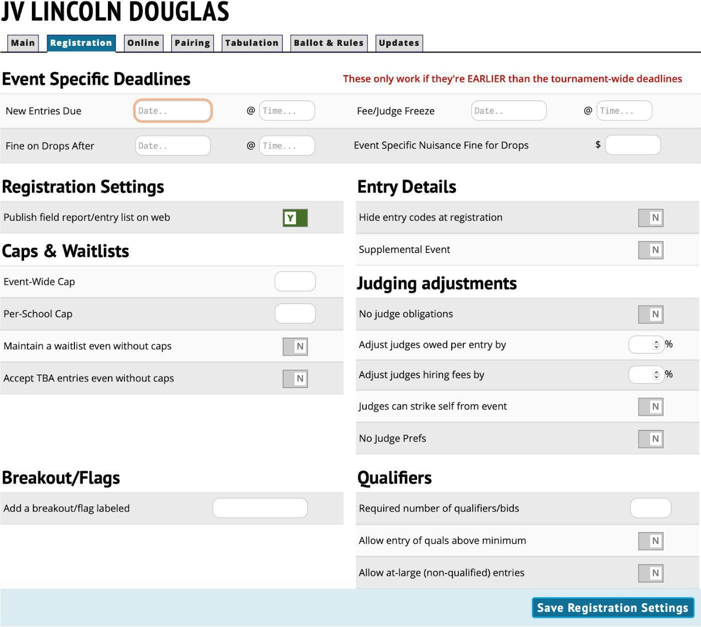

Online
New this year is the Online tab! As one might expect, it allows you to indicate if this event of your tournament is being held digitally.

- Online Options
  - Online Event: Choose if so.
  - Read notes about Observers from Tabroom and act accordingly.
  - Asynchronous links to online videos: Debates CAN be held asynchronously, but due to the time-restrictive nature of debate, this is not recommended. One major concern is that a large competitive aspect of debate is the limited amount of prep time in round, as well as lack of access to outside resources once the round has started. Tabroom will consider the end of your scheduled round time to be the time that ballots are due if the round is asynchronous, so if you wish to host to an asynchronous debate tournament - perhaps to allow for various technical issues and situations - you can counter these concerns by strictly limiting the round length.
  - Synchronous via pre-created room URLs: If hosting outside of NSDA Campus, check this box.
- Online Support Options: Self explanatory, instructions and contact e-mail that judges and competitors can use for help.
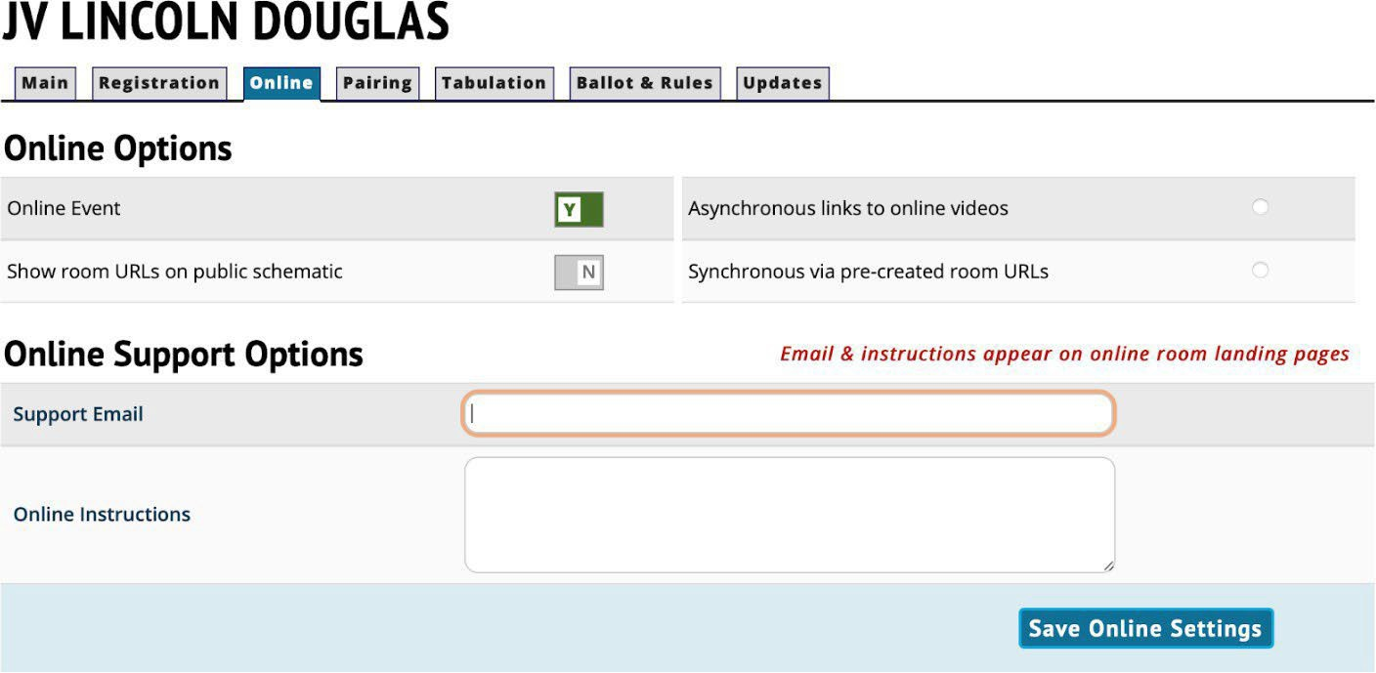

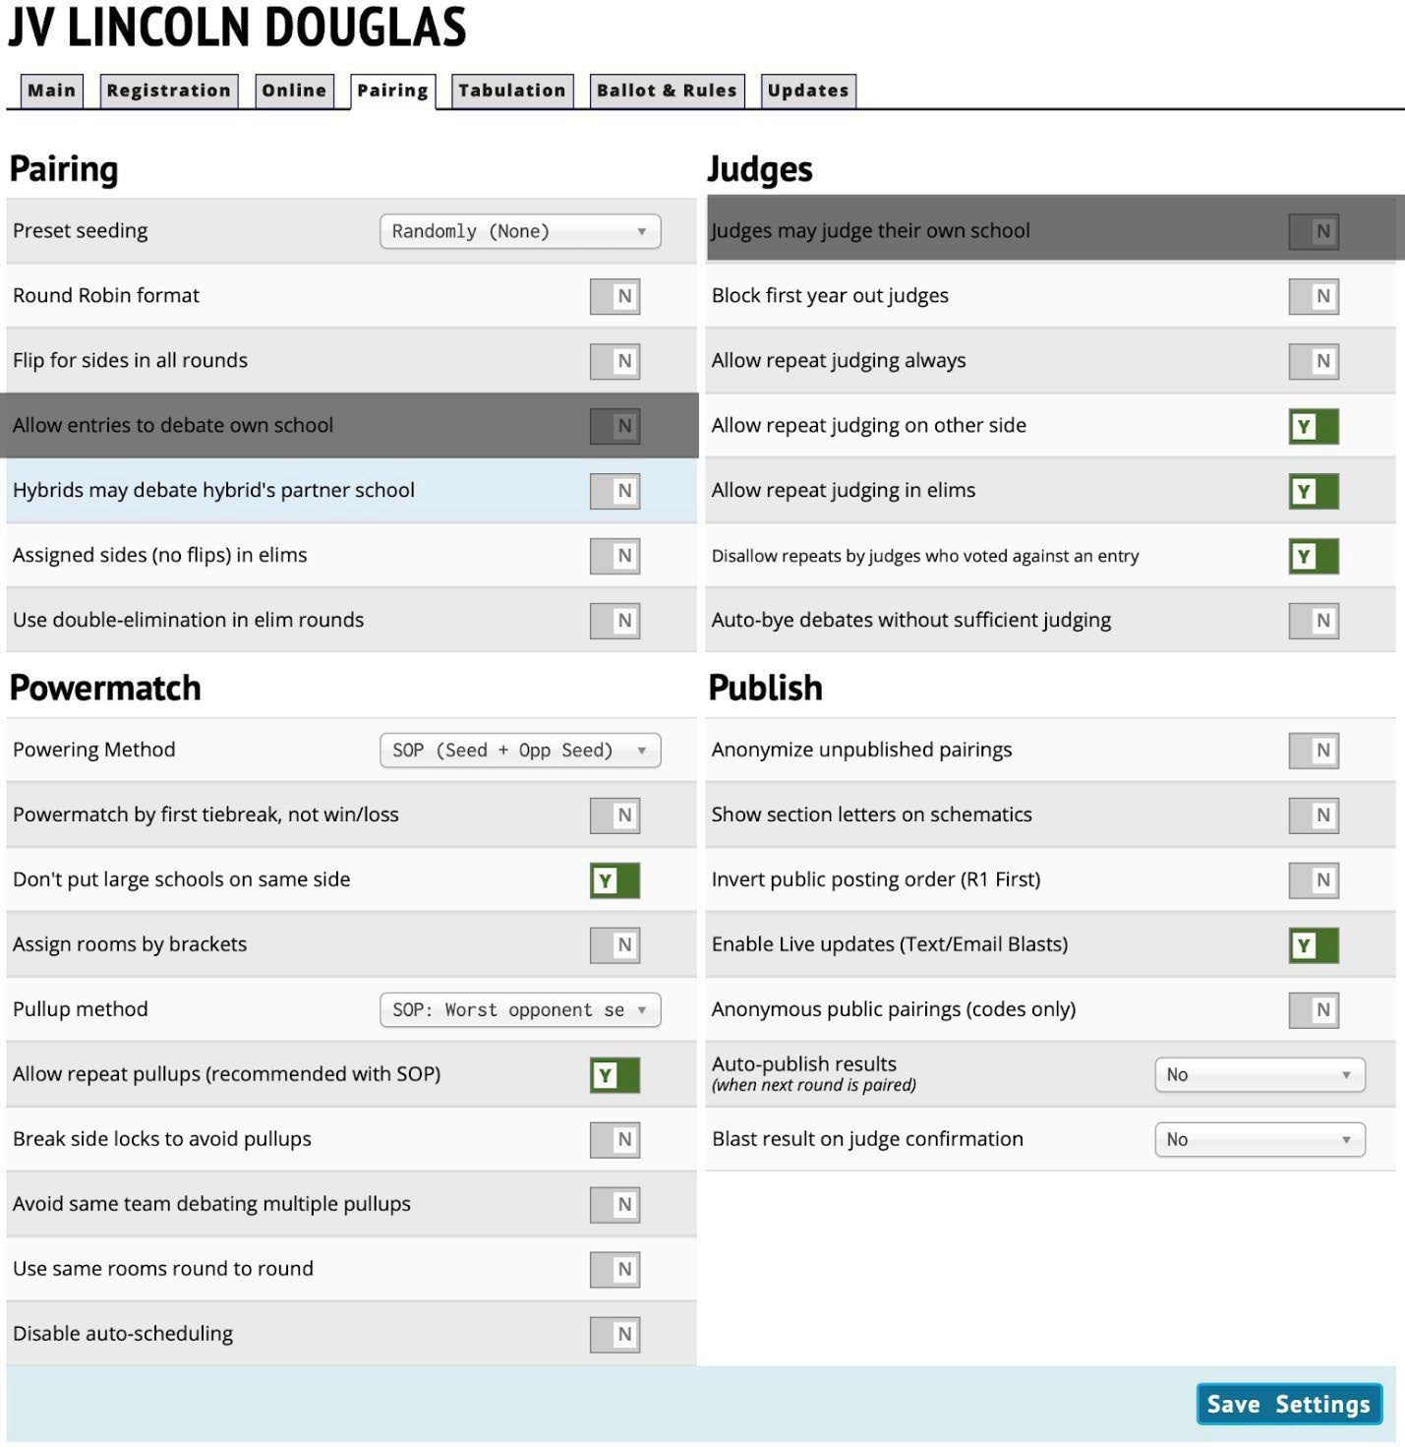

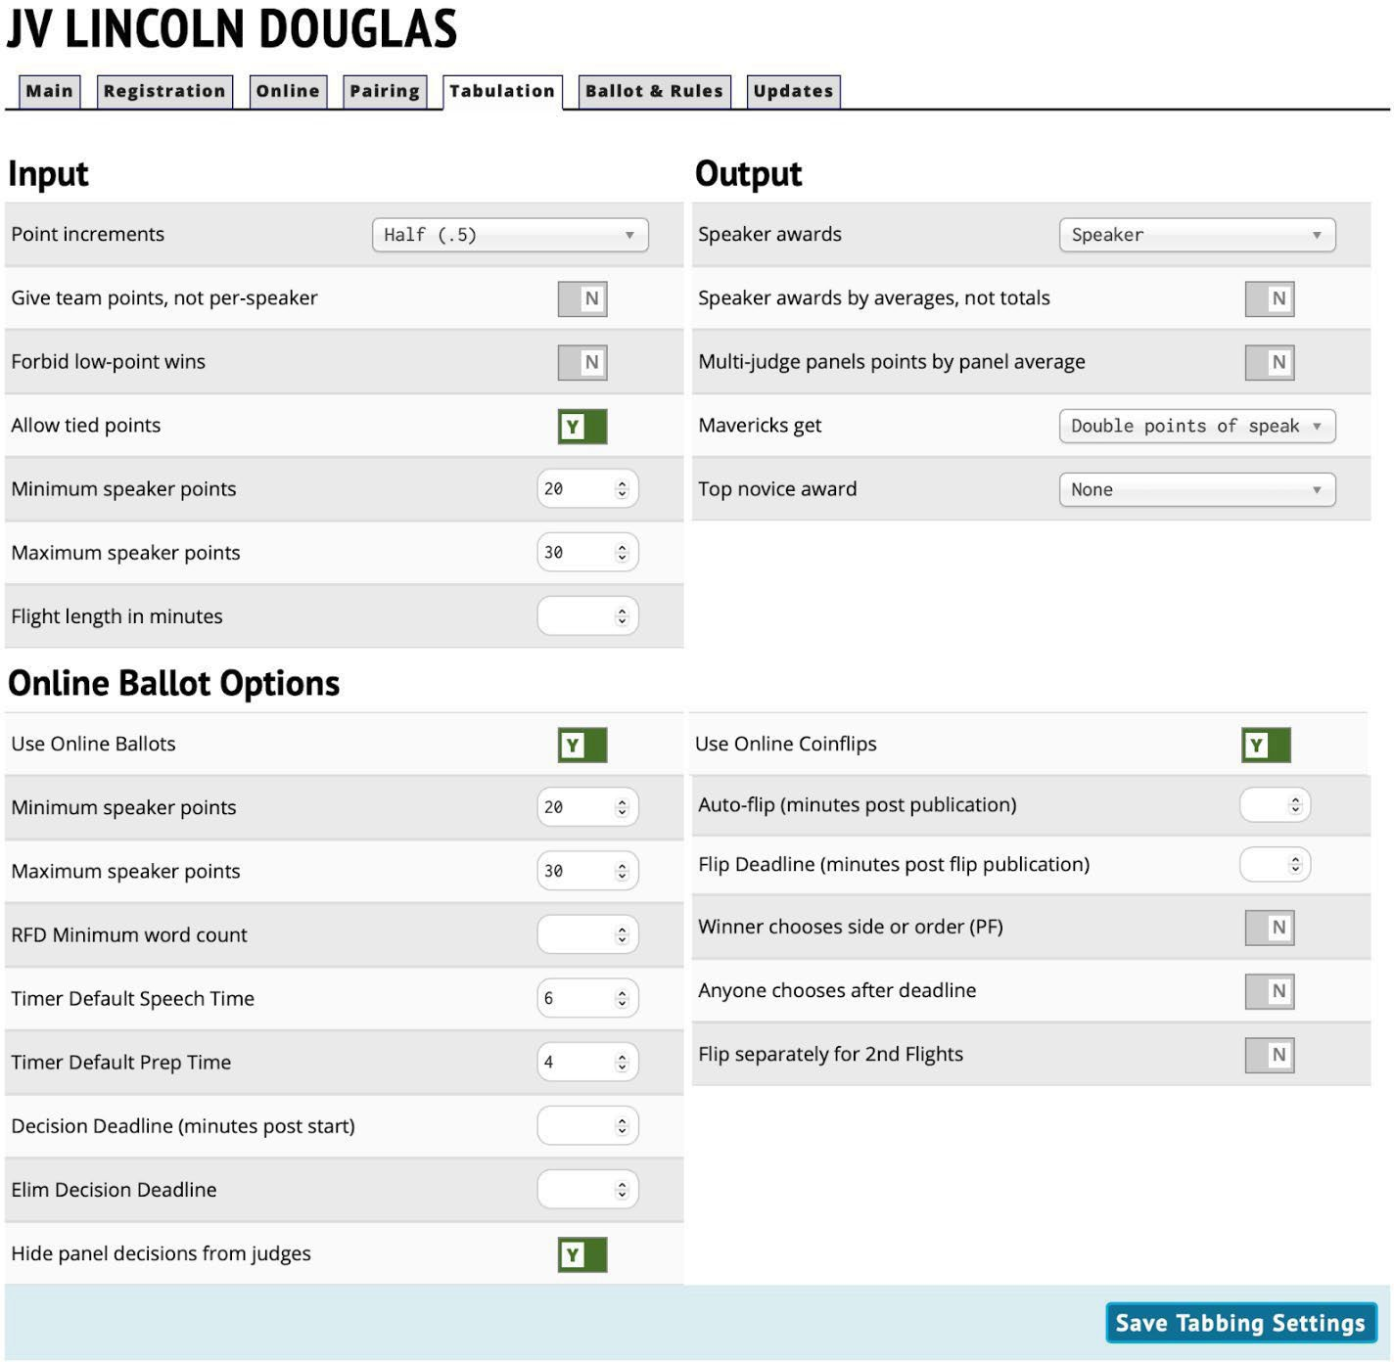
ffff

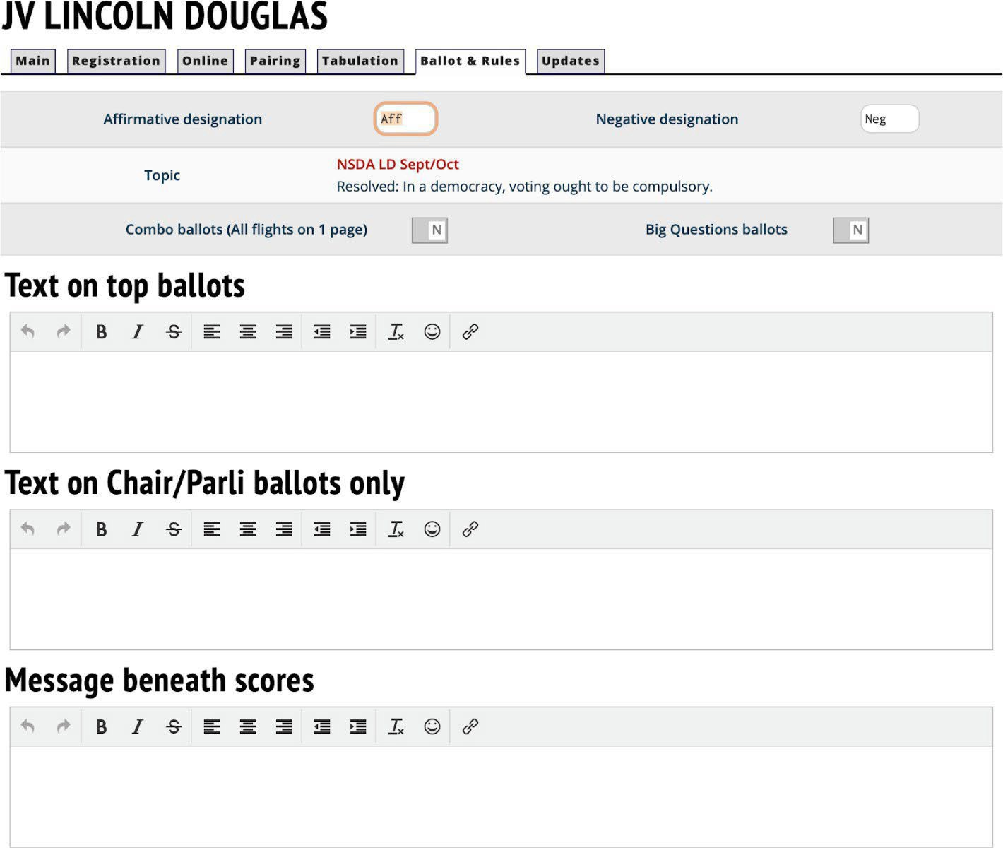
ff

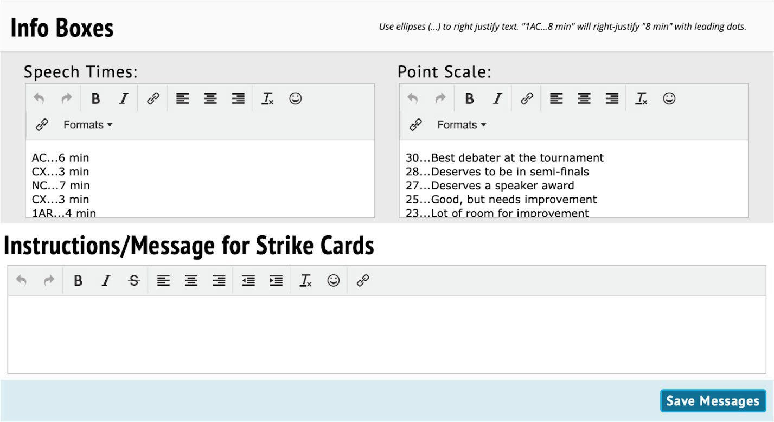
fff
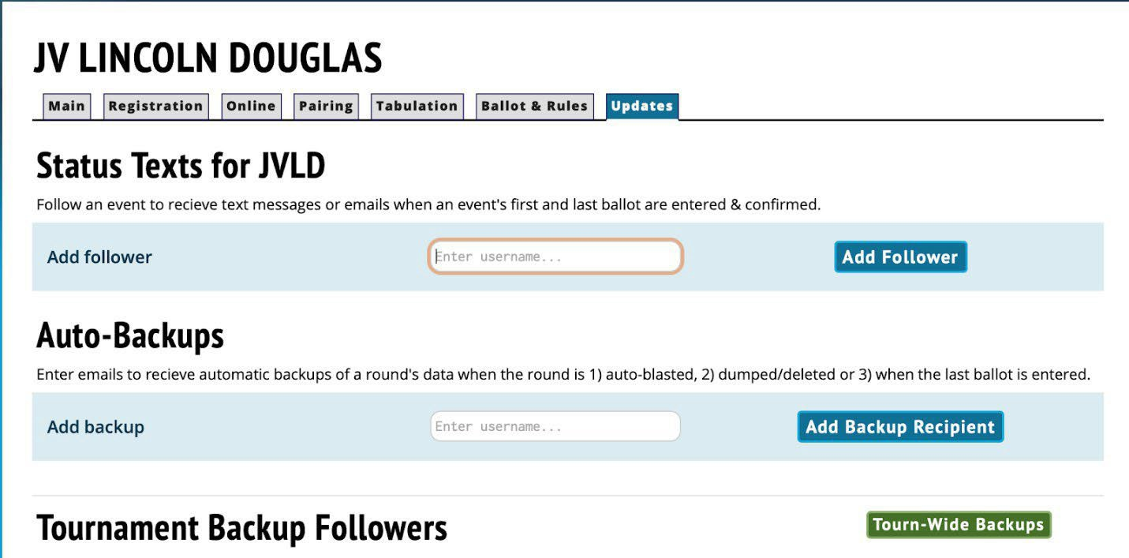

Tiebreaks Tab:
1. TIEBREAKS tab

There will likely be a default collection of tiebreak rules on the right. You need to click on each of these and delete them away so we can set up the KHSSL rules tiebreak tabs.

Finished with that?

Now click on Add a New Set. DEBATE PRELIMS:
Type in Debate Prelims as the name of the Tiebreaker Set. Check the No shows/forfeits place last box. Push the Create Tiebreak Set button.

Now you should see a new screen that has the info you just entered as the top 1/3 of the screen. Scroll down to the bottom 1/3 of the screen under Add New Tiebreaker. Time to make some Tiebreaker rules.

Tiebreak Type: Winloss Priority: 1
Leave all the other boxes and clicks alone Create New Tiebreak – push this button
You should now see this rule listed in the middle 1/3 of the screen as the first Tiebreaker for Debate Prelims. Good job, you.

There are six more tiebreakers for Debate Prelims, so let’s create them. Create New Tiebreak – push this button
Tiebreak Type: Points Priority: 2.
In the box to the right, by Drop Scores, click 1, and in the dropdown box, click High & Low

Create New Tiebreak – push this button Tiebreak Type: Points

Priority: 3

Leave all the other boxes and clicks alone

SAVE SETTINGS (toward top of page) – press this button Create New Tiebreak – push this button
Tiebreak Type: Judge Variant Points Priority: 4
Leave all the other boxes and clicks alone

SAVE SETTINGS (toward top of page) – press this button Create New Tiebreak – push this button
Tiebreak Type: Opponents’ avg wins Priority: 5
Leave all the other boxes and clicks alone

SAVE SETTINGS (toward top of page) – press this button Create New Tiebreak – push this button
Tiebreak Type: Points Priority: 6
In the box to the right, by Drop Scores, click 2, and in the dropdown box, click High & Low

SAVE SETTINGS (toward top of page) – press this button Create New Tiebreak – push this button

Tiebreak Type: Coinflip Priority: 7
Leave all the other boxes and clicks alone

SAVE SETTINGS (toward top of page) – press this button This is what your screen should now look like.

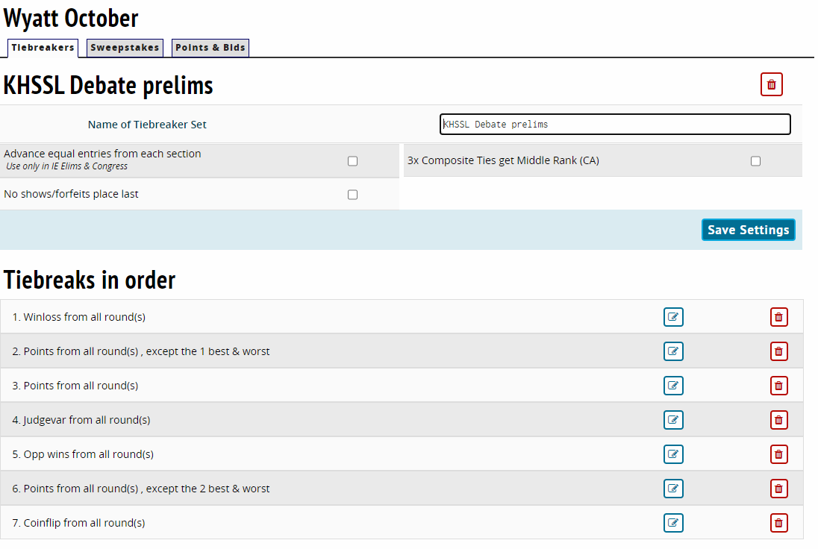
Now click on Add a New Set. DEBATE SPEAKER:
Type in Debate Speaker as the name of the Tiebreaker Set. Check the No shows/forfeits place last box. Push the Create Tiebreak Set button.

Now you should see a new screen that has the info you just entered as the top 1/3 of the screen. Scroll down to the bottom 1/3 of the screen under Add New Tiebreaker. Time to make some Tiebreaker rules.

Tiebreak Type: Points Priority: 1
In the box to the right, by Drop Scores, click 1, and in the dropdown box, click High & Low Create New Tiebreak – push this button
You should now see this rule listed in the middle 1/3 of the screen as the first Tiebreaker for Debate Speaker. Good job, you.

There are five more tiebreakers for Debate Speaker, so let’s create them. Create New Tiebreak – push this button
Tiebreak Type: Points Priority: 2.
In the box to the right, by Drop Scores, click 2, and in the dropdown box, click High & Low SAVE SETTINGS (toward top of page) – press this button
Create New Tiebreak – push this button Tiebreak Type: Points
Priority: 3

Leave all the other boxes and clicks alone

SAVE SETTINGS (toward top of page) – press this button Create New Tiebreak – push this button
Tiebreak Type: Opp wins Priority: 4
Leave all the other boxes and clicks alone

SAVE SETTINGS (toward top of page) – press this button Create New Tiebreak – push this button
Tiebreak Type: Judgsvar2 Priority: 5
Leave all the other boxes and clicks alone

SAVE SETTINGS (toward top of page) – press this button Create New Tiebreak – push this button
Tiebreak Type: Coinflip

Priority: 6

Leave all other boxes and clicks alone

SAVE SETTINGS (toward top of page) – press this button This is what your screen should now look like.
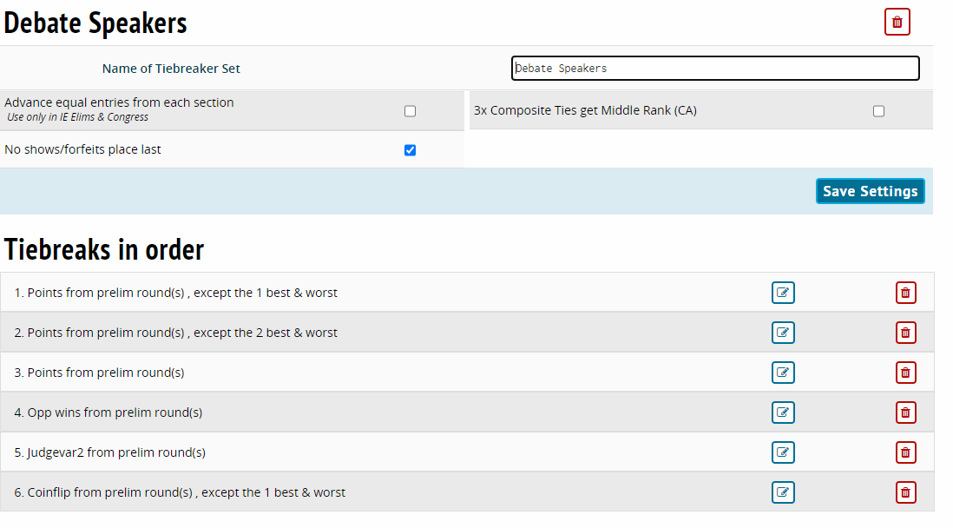

CONGRESSIONAL DEBATE
When you set it up as an event, make sure to select it as a Congress event type, or you won’t get the Legislation tab to appear.
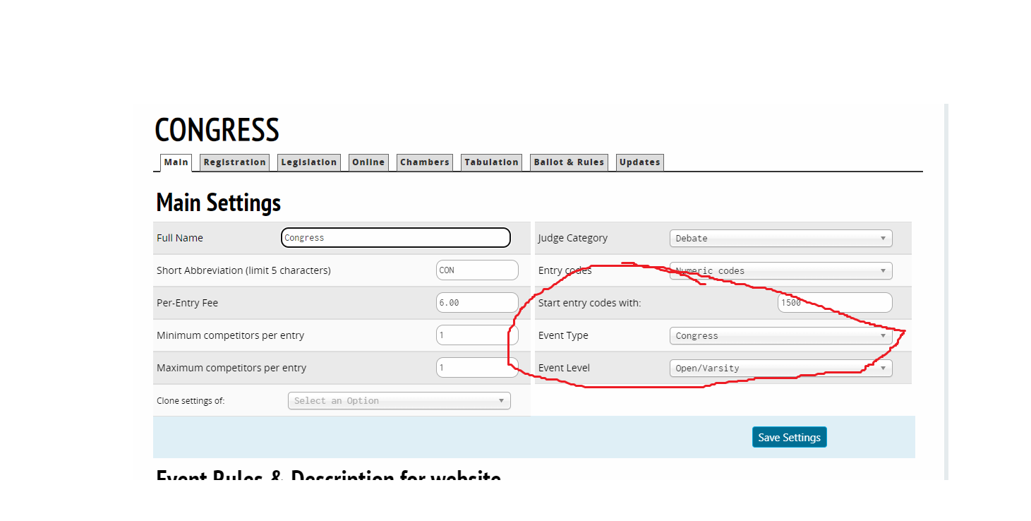

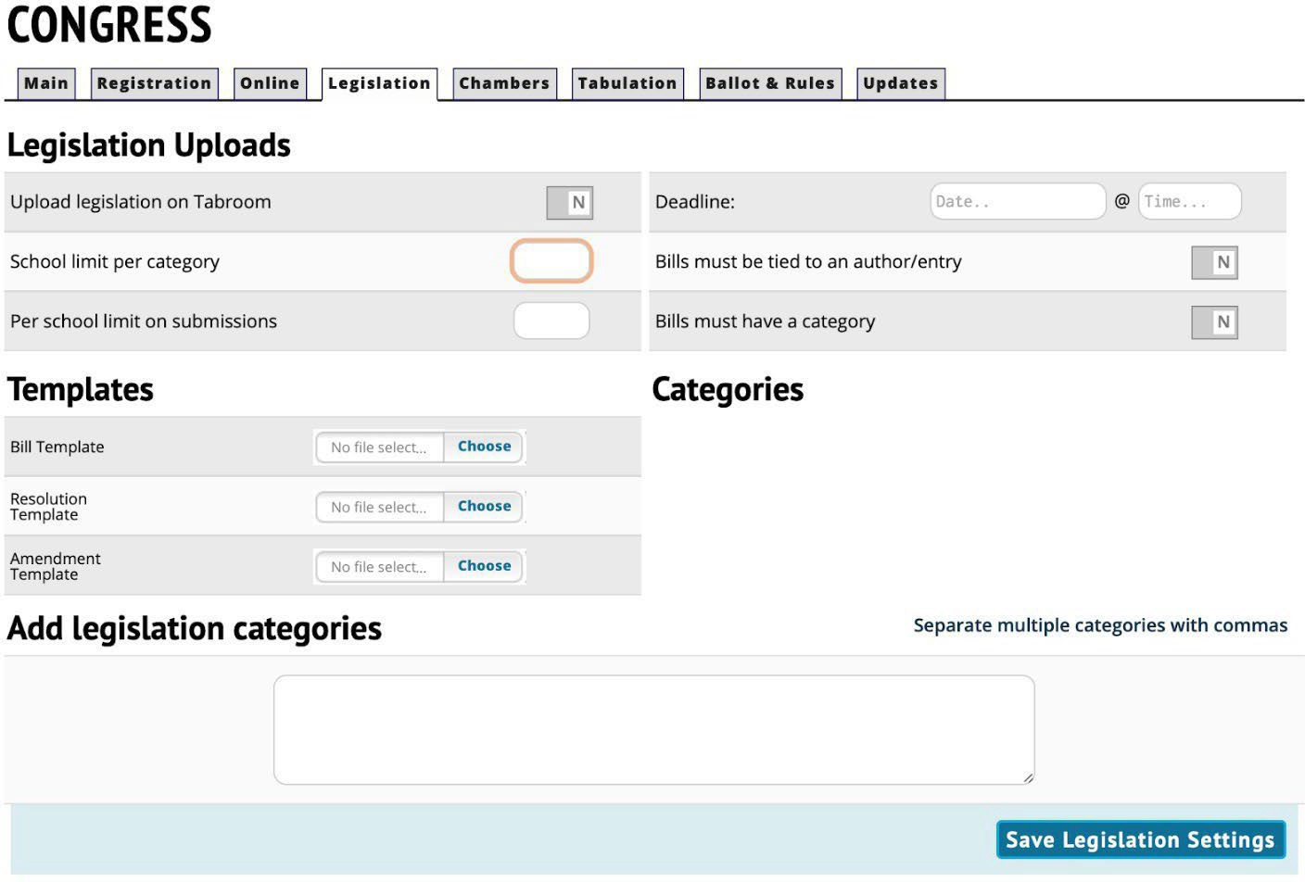

I encourage you to check the first box to Y and run your legislation through Tabroom, even if you are going to create a legislation booklet. That way you have all the legislation in one place.
You can choose to limit legislation (number submitted) or not. Most invitationals need all they can get., so I wouldn’t necessarily do it unless you think you’ll have way too much.
KHSSL has provided templates for Bills, Resolutions, and Amendments you can upload. They can be found here:
https://www.khssl.org/congressional-debate

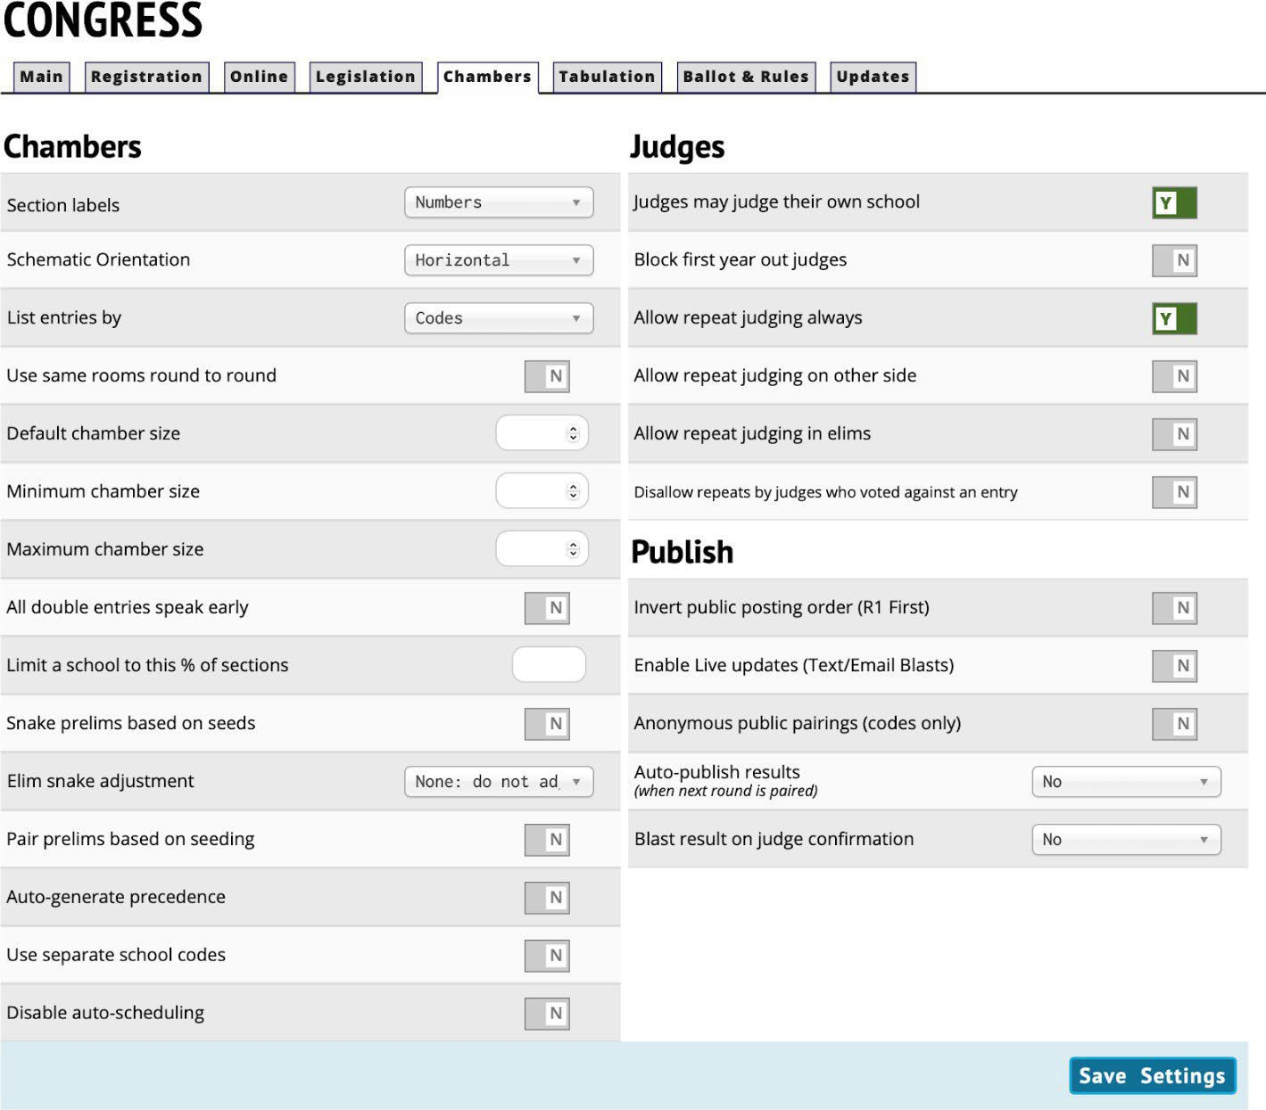

Don’t go over 24 in a chamber. If online, keep it much lower as only so many boxes will fit on a screen. Make sure to allow judges to judge their own school unless you have a billion extra judges.

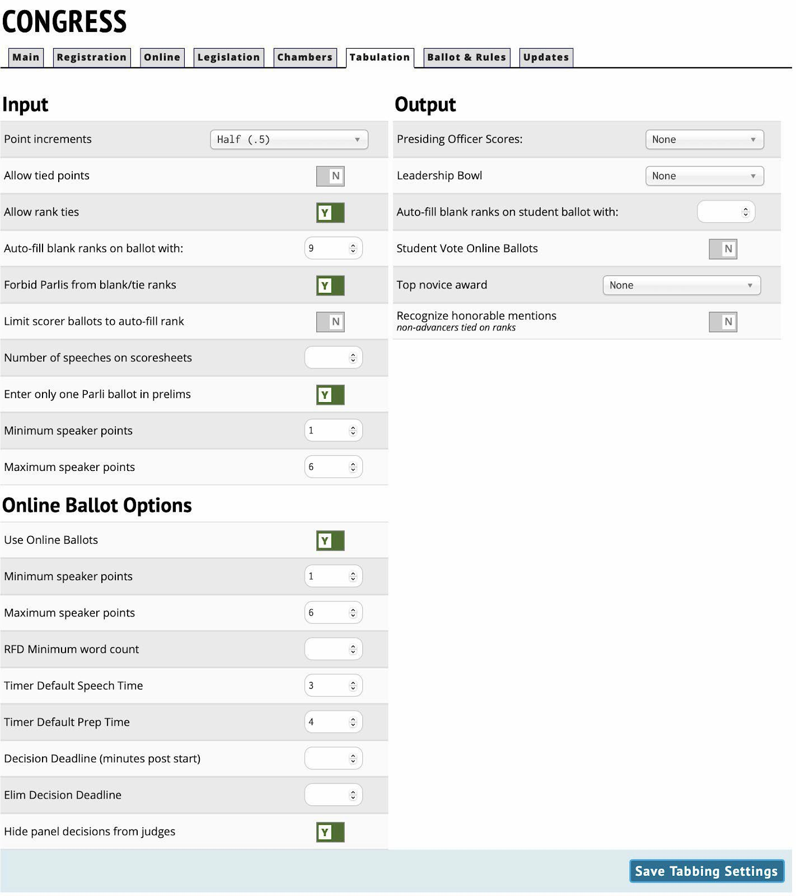
Do all this.

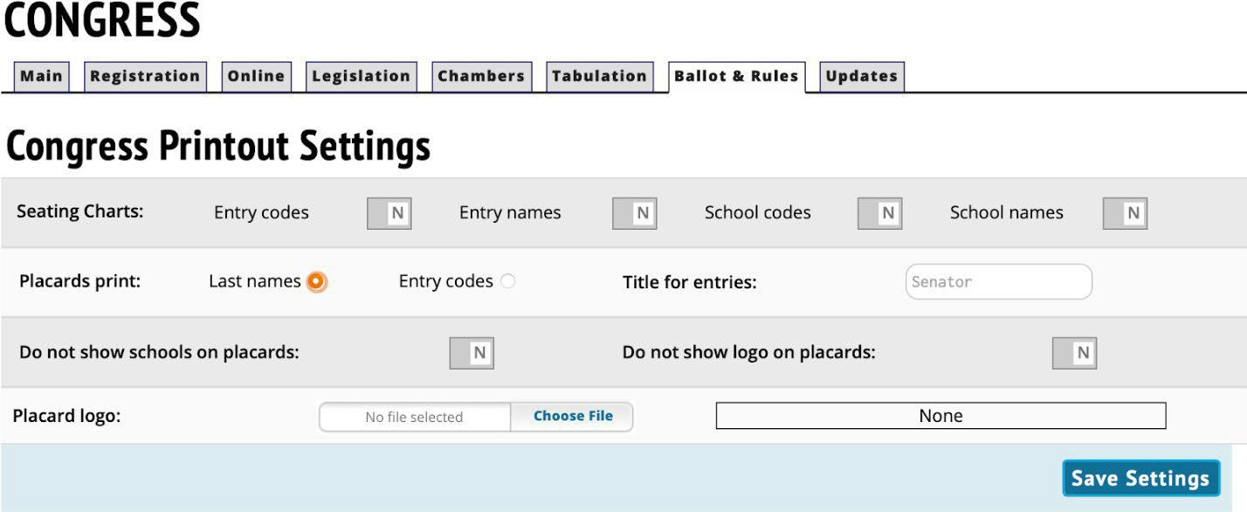

If you are printing placards (and that’s really cool for in person meets), do it on cardstock. Call them Senators as they like that. Put your tournament logo in for the placard logo – they’ll all have a souvenir!

SCHEDULE TAB:
On the schedule tab, in the first box, name the round. Under start time, add the time the round starts (there are separate boxes for AM and PM, so make sure you are in the right one), under end time, add the time the round ends. Then click add. When you move to power matched rounds, give yourself extra time between when one round ends and the next begins. You cannot power a round until every ballot is turned in.
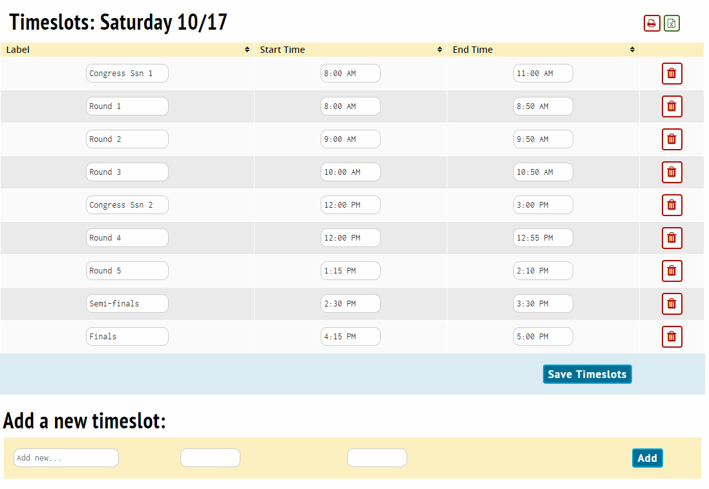

The next picture is a sample what an event’s schedule may look like.
